### **Comprehensive Linux Operations**

#### **Project Overview**

This project spans various aspects of Linux system administration, including file management, user and group management, service control, process handling, and more. You will be completing tasks that simulate real-world scenarios, providing hands-on experience with Linux commands and configurations.

### **Project Breakdown**

#### **Part 1: Creating and Editing Text Files (20 minutes)**

**Scenario:** You are tasked with documenting the configurations and settings for a new server. You'll use different text editors to create and update these documents.

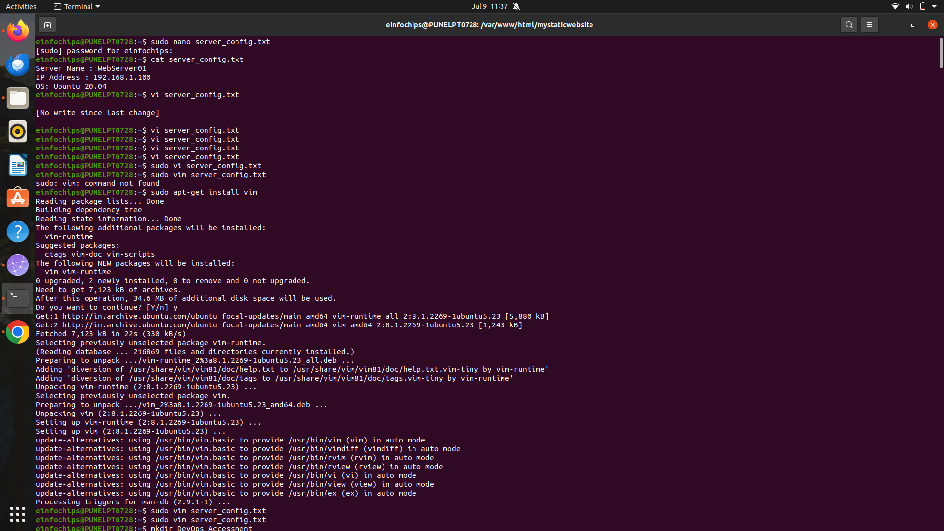

#### **Part 2: User & Group Management (20 minutes)**

**Scenario:** You need to set up user accounts and groups for a new team joining the project.

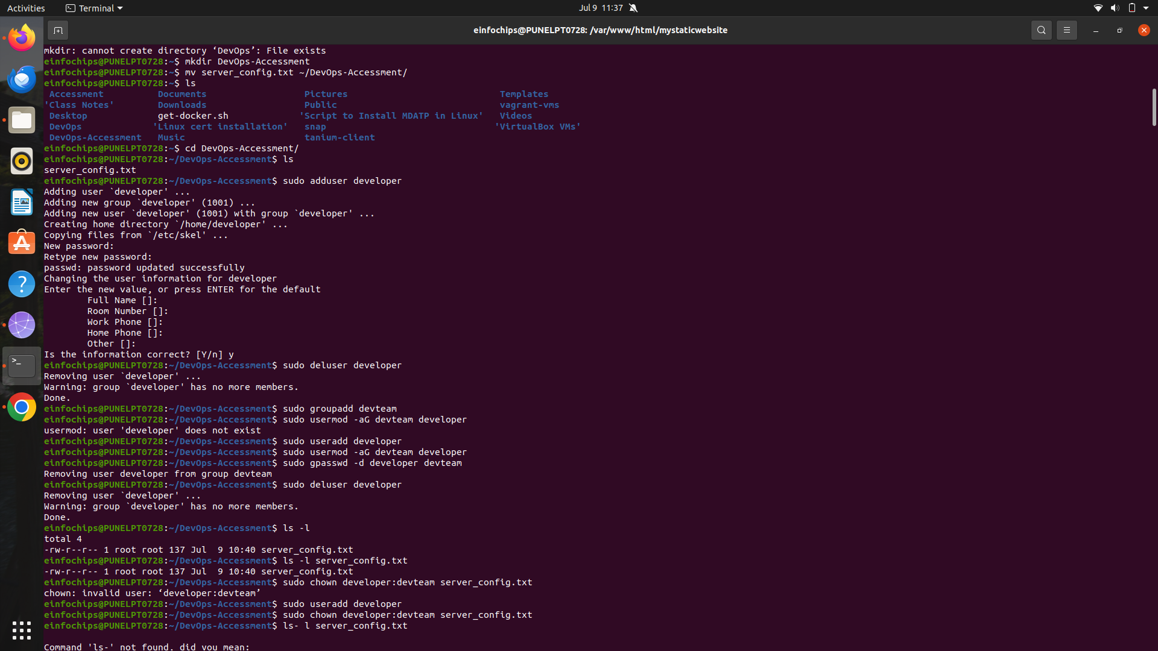

#### **Part 3: File Permissions Management (20 minutes)**

**Scenario:** Ensure that only the appropriate users have access to specific files and directories.

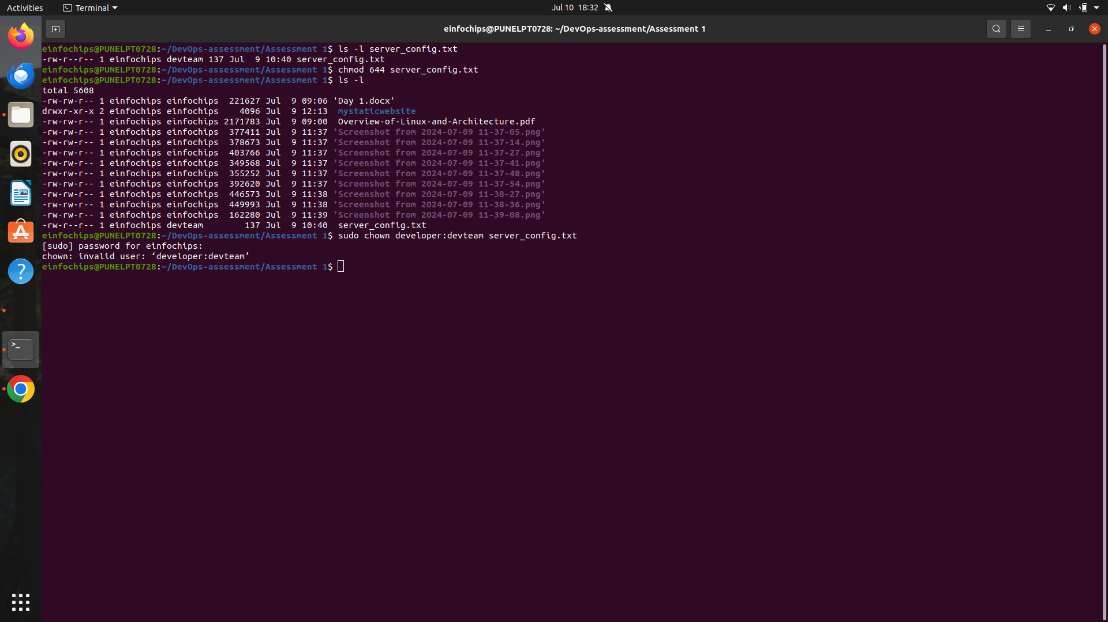

#### **Part 4: Controlling Services and Daemons (20 minutes)**

**Scenario:** Manage the web server service to ensure it is running correctly and starts on boot.

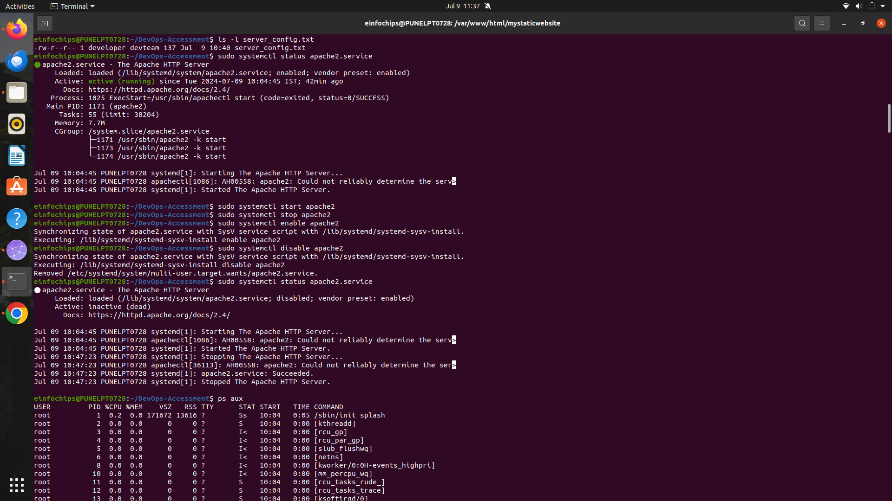

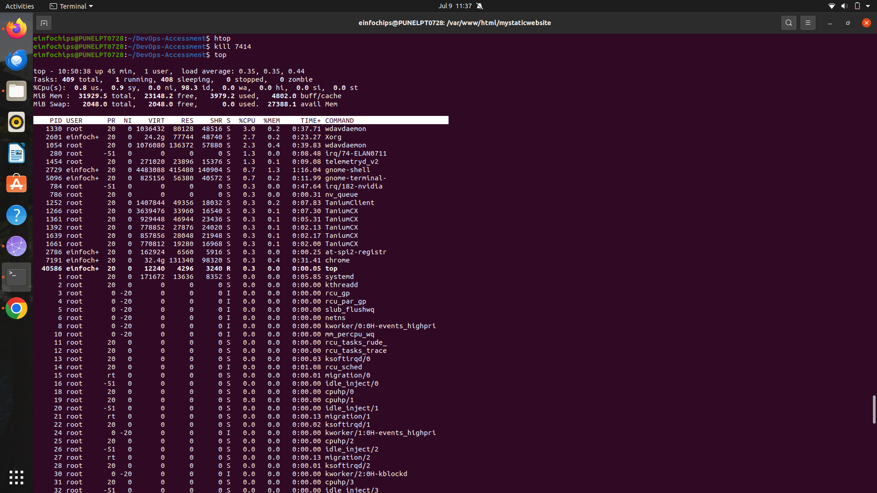

#### **Part 5: Process Handling (20 minutes)**

**Scenario:** Monitor and manage processes to ensure the server is performing optimally.

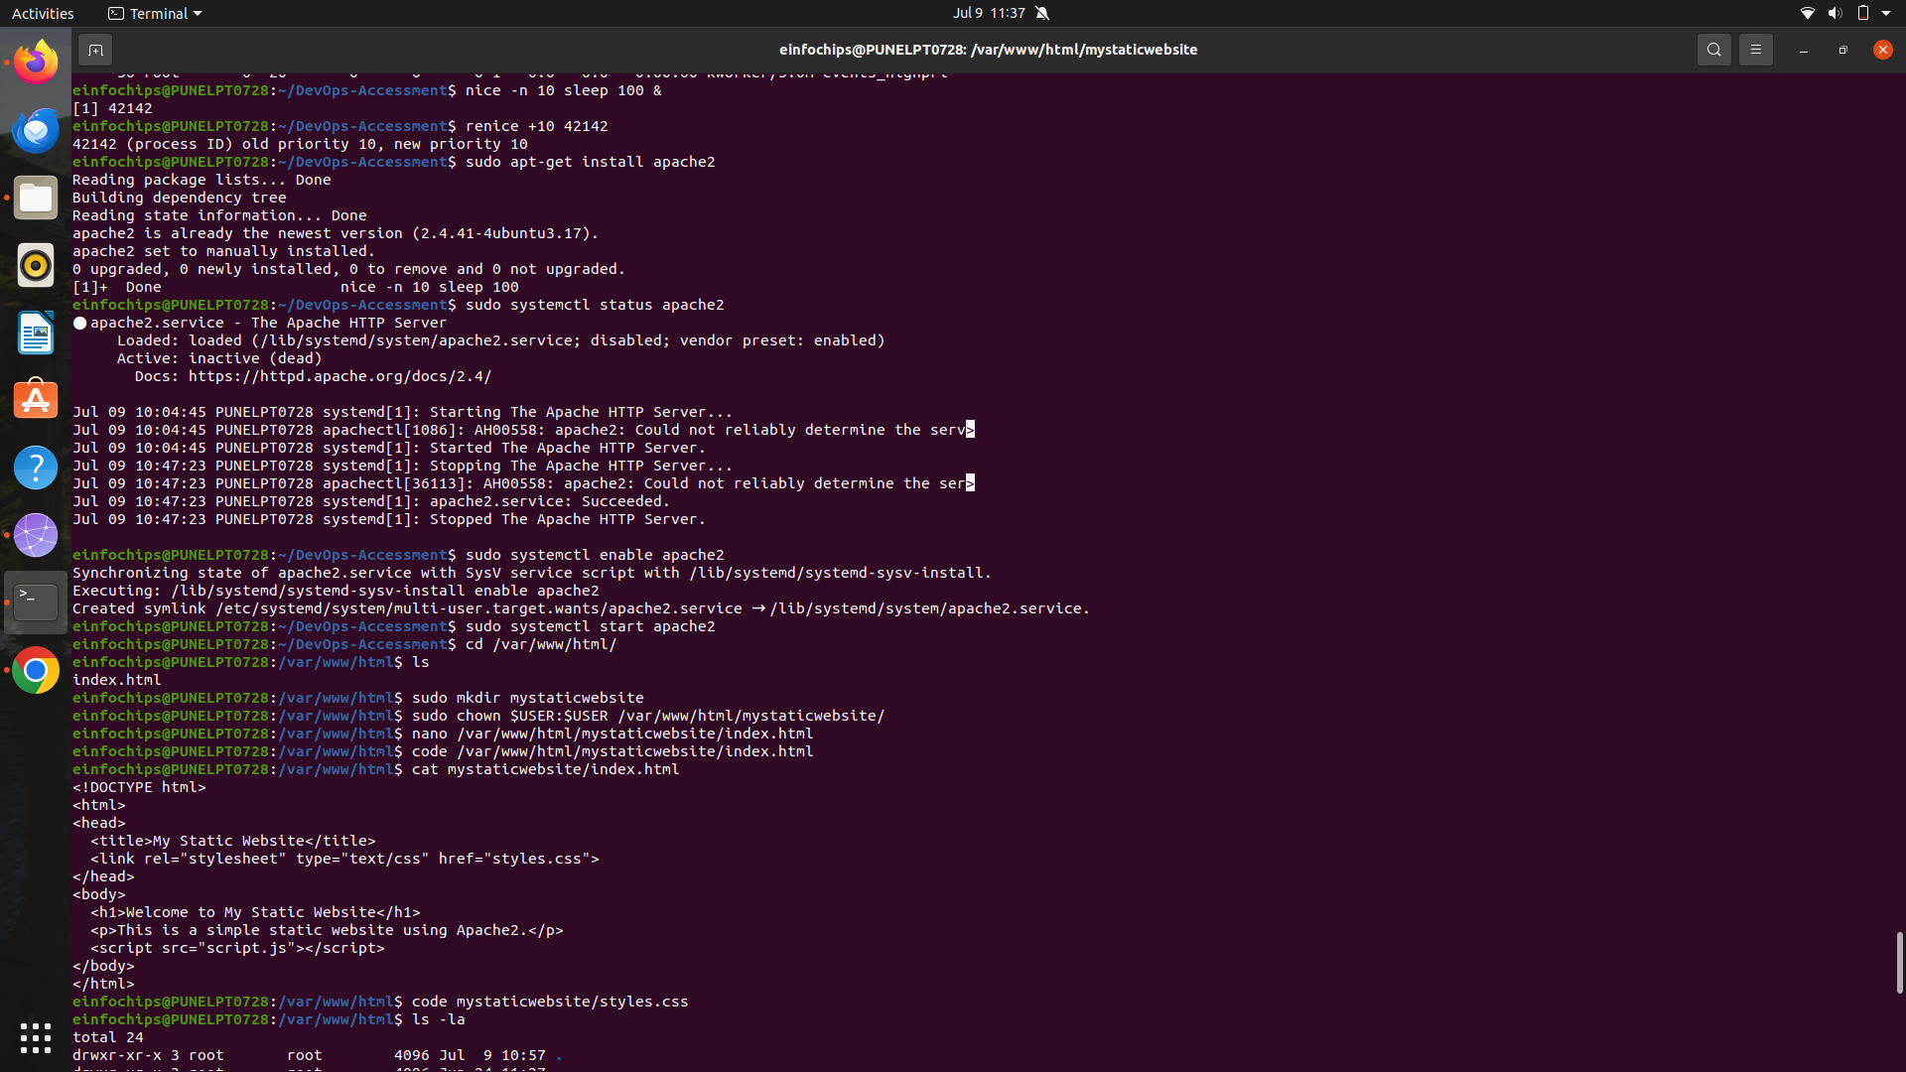

### **Creating and Deploying a Static Website with Apache2**

#### **Preparation (5 minutes)**

* Ensure you have access to a Linux environment (e.g., virtual machines, EC2 instances, or local installations) with sudo privileges.

### **Activity Breakdown**

#### **Part 1: Installing Apache2 (5 minutes)**

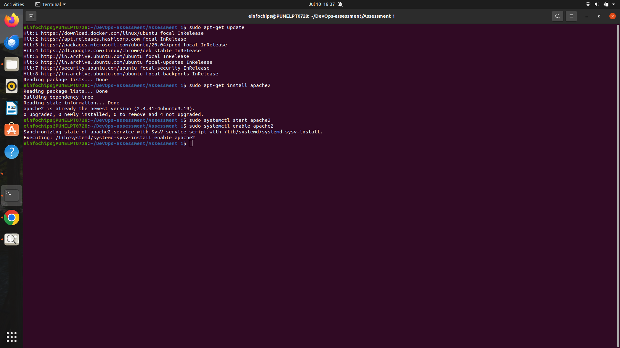

#### **Part 2: Creating the Website (10 minutes)**



#### **Part 3: Configuring Apache2 to Serve the Website (10 minutes)**

